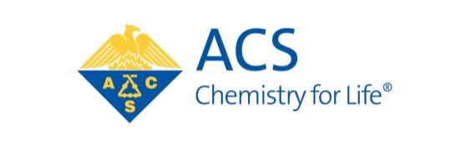
The E. Ann Nalley Award for Volunteer Service to the American Chemical Society

Purpose: To recognize the volunteer efforts of individuals who have served the American Chemical Society, contributing significantly to the goals and objectives of the Society through their Regional Activities.

Nature and Establishment: This award was instituted in 2006 by ACS President E. Ann Nalley as part of her presidential initiative to recognize ACS volunteerism. It was Dr. Nalley’s wish that the award continue in perpetuity at each regional meeting. The award consists of a plaque honoring the recipient with an imbedded medallion commemorating Dr. Nalley.

Rules of Eligibility: A nominee must be a member of the American Chemical Society residing in a local section within the region and will have made significant contributions to their Region of the American Chemical Society. The volunteerism to be recognized may include a variety of activities, including but not limited to the initiation or sponsorship of a singular endeavor or exemplary leadership in the region. Past and present members of the ACS Board of Directors and staff are ineligible for this award.

DEADLINE: August 15th, 2025

Directions: Any individual, except a member of the award selection committee, may nominate or support only one nominee for this award in any given year. Please complete all fields.

Submittal process: Submit each of the following: nomination and support forms, and biographical sketch (or curriculum vitae) to Dr. Natalie McClure as an e-mail attachment to nmcclure@drugregulatoryaffairs.com.

The Award will be presented as part of the Western Regional Meeting of the ACS, which will be held Monday, October 27, 2025.

The E. Ann Nalley Award for Volunteer Service to the American Chemical Society

NOMINATION FORM

Submission Date:
NOMINATOR INFORMATION
First Name:
Last Name:
Company or Institutional Affiliation:
Present Position:
Address:
City:
State, Zip code:
Telephone:
Email:
NOMINEE INFORMATION
First Name:
Last Name:
Local Section:
Company or Institutional Affiliation:
Present Position:
Address:
City:
State, Zip Code:
Home Telephone: Fax:
Email:
Website:
Has this nomination been discussed with the nominee?

Attachments:
- Please provide a brief narrative summary evaluating the nominee’s volunteer accomplishments and service to the region. Explain why the nominee is being recommended for this award with regard to the stated purposes of the award.
- Provide the nominee’s brief biographical sketch (or curriculum vitae).
- Up to 2 letters of support for this nomination

