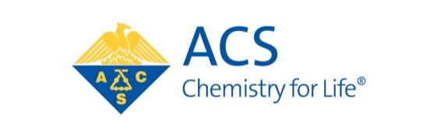

Partners in Progress
and Prosperity (P3) award

Purpose: This award is designed to encourage and recognize successful and exemplary partnerships. These partnerships can be between industry, academia, government, small business and/or other organizations, including ACS local sections with other organizations which result in impactful outcomes in one of the following categories:
- Improving the public perception and appreciation for chemistry
- Promoting career advancement opportunities and/or supporting entrepreneurship in the chemistry enterprise
- Advancing advocacy efforts with government and other thought leaders
- Supporting STEM education and/or research.

The award consists of a special medal and certificate of recognition; a cash award of $1000 to be split equally between the partners is to further support the activities being recognized.
Eligibility: A nominee may represent academia, industry, government, small business or other organizations such as a local section

DEADLINE: August 15th, 2025

Directions: Any individual, except a member of the award selection committee, may nominate or support only one nominee for this award in any given year. Please complete all fields.

Submittal process: Submit each of the following: nomination and support forms, and biographical sketch (or curriculum vitae) to Dr. Natalie McClure as an e-mail attachment to nmcclure@drugregulatoryaffairs.com.

The Award will be presented as part of the Western Regional Meeting of the ACS, which will be held Monday, October 27, 2025.

The Partners in Progress and Prosperity Award

NOMINATION FORM

Submission Date:
NOMINATOR INFORMATION
First Name:
Last Name:
Company or Institutional Affiliation:
Present Position:
Address:
City:
State, Zip code:
Telephone:
Email:
NOMINEE INFORMATION
First Name:
Last Name:
Local Section:
Company or Institutional Affiliation:
Present Position:
Address:
City:
State, Zip Code:
Home Telephone: Fax:
Email:
Website:
Has this nomination been discussed with the nominee?

Attachments:
- Please provide a brief narrative summary describing the partnership, its activities, outcomes and impacts. Explain why the nominee is being recommended for this award with regard to the stated purposes of the award.
- Up to 2 letters of support for this nomination

